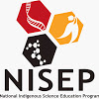
Wagga Wagga NISEP Training Day

Thursday 24th July 2014

Charles Sturt University, Wagga Wagga

The National Indigenous Science Education Program (NISEP) and Charles Sturt University (CSU) invite you to participate in a day designed to train science students in a number of laboratory based experiments. This will enable them to demonstrate to younger, fellow students at their schools and provide them with an opportunity to engage in a leadership role, while developing valuable communication skills. Additionally, the day will provide collaboration between a number of schools, institutions and community representatives.

Program
10:15am - Meet at the National Life Sciences Hub (NaLSH) at Charles Sturt University
10:20am - Brief introduction and welcome
10:20am – Training and workshop activities
12:20pm - Lunch on the grassed area near the tennis courts (weather permitting)
13:20pm - Wrap-up and close
13:30pm - Schools depart

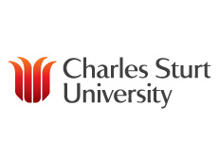
We thank you for your participation in the day’s events and hope you enjoyed yourselves.

Contacts:
Clare Flakelar
M: 0400608957
E: cflakelar@csu.edu.au

Dan Bedgood
E: dbedgood@csu.edu.au
Paul Prenzler
E: pprenzler@csu.edu.au

